UART-Based Digital Monitoring and Control System
Project Description
This project implements a UART-based digital monitoring and control system using Verilog HDL.
The system receives serial data through UART, processes the received data, generates a control output, and transmits the received data through UART.
The design is developed and verified using Xilinx Vivado.
Objectives
- To design a UART-based digital monitoring and control system using Verilog HDL.
- To receive serial data through UART.
- To generate a control output based on the received data.
- To verify the design using simulation.
Design Description
The system consists of a Baud-Rate Clock Divider, UART Receiver, Control Logic, and UART Transmitter. The received serial data is converted into 8-bit digital data and processed to generate the required control output.
Design Code
`timescale 1ns / 1ps

module uart_monitoring_control (
input wire clk,
input wire reset,
input wire rx,
output reg tx,
output reg control_out,
output reg [7:0] received_data
);

// Baud-rate clock divider
reg [3:0] baud_counter;
reg baud_tick;

// UART receiver
reg [3:0] rx_bit_count;
reg [7:0] rx_shift_reg;
reg rx_busy;

// UART transmitter
reg [3:0] tx_bit_count;
reg [7:0] tx_shift_reg;
reg tx_busy;

// Baud tick generation
always @(posedge clk or posedge reset) begin
if (reset) begin
baud_counter <= 0;
baud_tick <= 0;
end
else begin
if (baud_counter == 4'd9) begin
baud_counter <= 0;
baud_tick <= 1;
end
else begin
baud_counter <= baud_counter + 1;
baud_tick <= 0;
end
end
end

// UART Receiver
always @(posedge clk or posedge reset) begin
if (reset) begin
rx_bit_count <= 0;
rx_shift_reg <= 0;
rx_busy <= 0;
received_data <= 0;
end
else if (baud_tick) begin
if (!rx_busy && !rx) begin
rx_busy <= 1;
rx_bit_count <= 0;
end
else if (rx_busy) begin
rx_shift_reg[rx_bit_count] <= rx;

if (rx_bit_count == 4'd7) begin
received_data <= rx_shift_reg;
rx_busy <= 0;
rx_bit_count <= 0;
end
else begin
rx_bit_count <= rx_bit_count + 1;
end
end
end
end

// Control logic
always @(posedge clk or posedge reset) begin
if (reset)
control_out <= 0;
else if (received_data == 8'h01)
control_out <= 1;
else if (received_data == 8'h00)
control_out <= 0;
end

// UART Transmitter
always @(posedge clk or posedge reset) begin
if (reset) begin
tx <= 1;
tx_bit_count <= 0;
tx_shift_reg <= 0;
tx_busy <= 0;
end
else if (!tx_busy && received_data != 0) begin
tx_busy <= 1;
tx_bit_count <= 0;
tx_shift_reg <= received_data;
tx <= 0;
end
else if (tx_busy && baud_tick) begin
if (tx_bit_count < 8) begin
tx <= tx_shift_reg[tx_bit_count];
tx_bit_count <= tx_bit_count + 1;
end
else begin
tx <= 1;
tx_busy <= 0;
tx_bit_count <= 0;
end
end
end

endmodule
Testbench Code
`timescale 1ns / 1ps

module tb_uart_monitoring_control;

reg clk;
reg reset;
reg rx;

wire tx;
wire control_out;
wire [7:0] received_data;

uart_monitoring_control DUT (
.clk(clk),
.reset(reset),
.rx(rx),
.tx(tx),
.control_out(control_out),
.received_data(received_data)
);

// Clock: 10 ns period
always #5 clk = ~clk;

initial begin
clk = 0;
reset = 1;
rx = 1;

#20;
reset = 0;

// Send start bit
#10 rx = 0;

// Send 8-bit data: 00000001
#100 rx = 1;
#100 rx = 0;
#100 rx = 0;
#100 rx = 0;
#100 rx = 0;
#100 rx = 0;
#100 rx = 0;
#100 rx = 0;

// Stop bit
#100 rx = 1;

#200;

$display("UART Simulation Completed");
$display("Received Data = %h", received_data);
$display("Control Output = %b", control_out);

$finish;
end

endmodule
Simulation Output
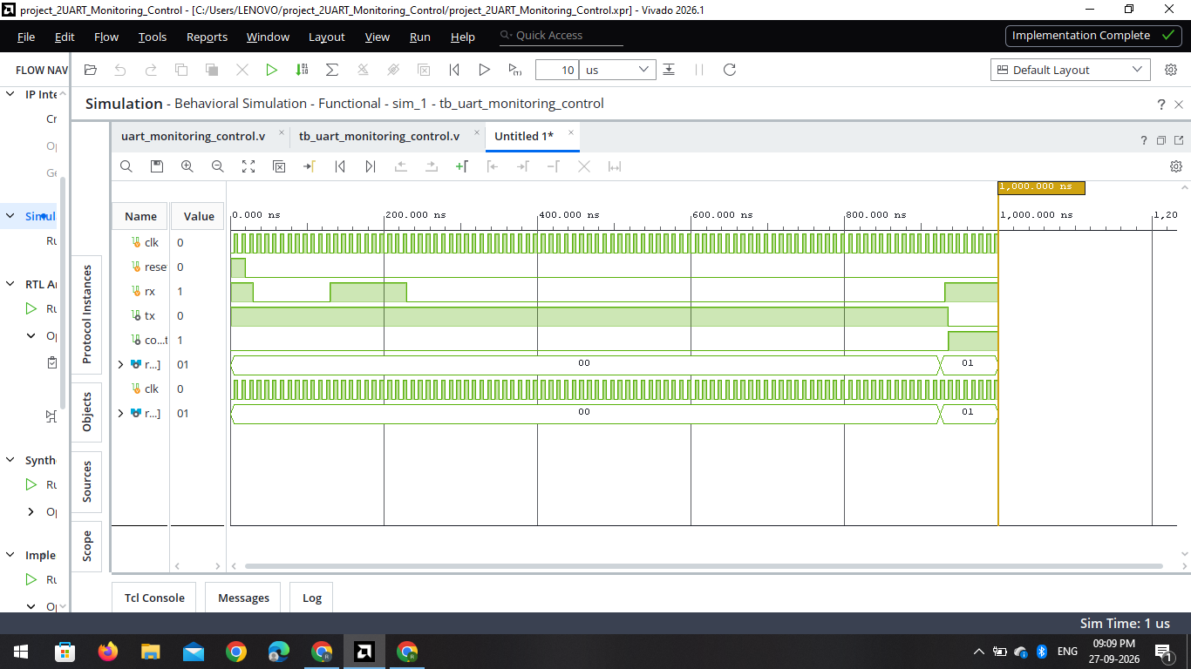
01_Simulation_Waveform.png
RTL Schematic
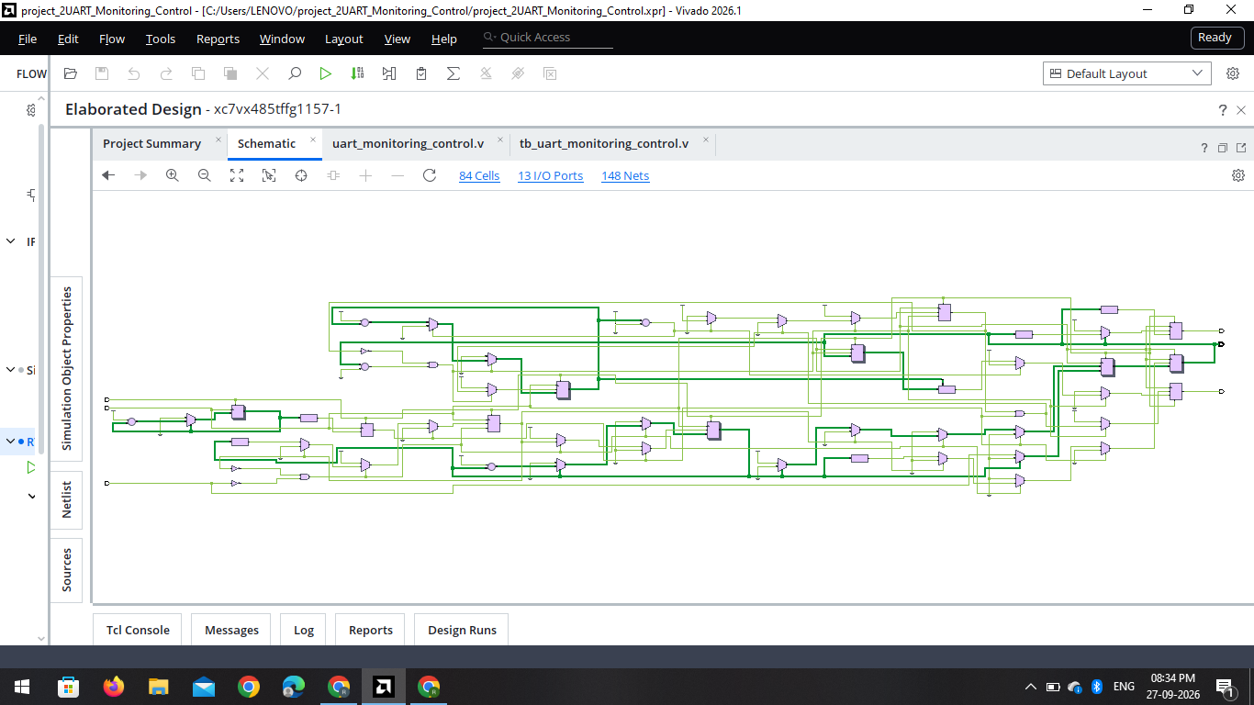
02_RTL_Schematic.png
Console Output

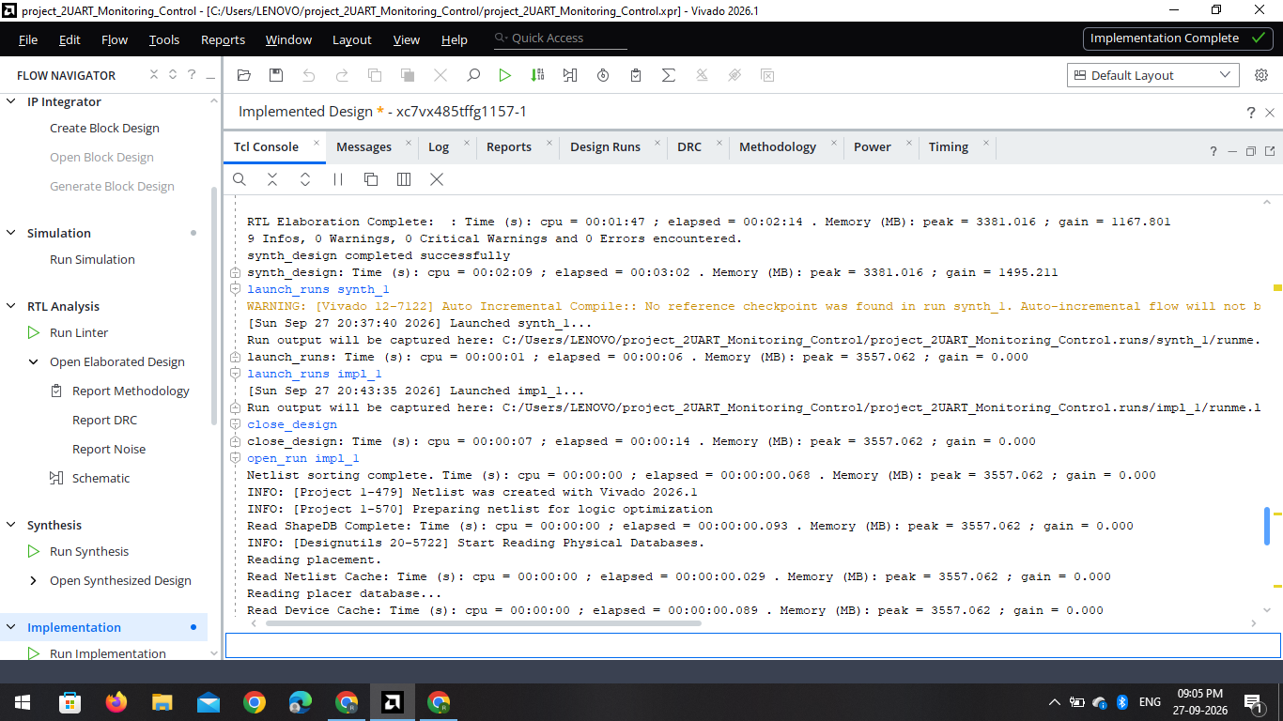
03_Console_Output.png
Power Analysis

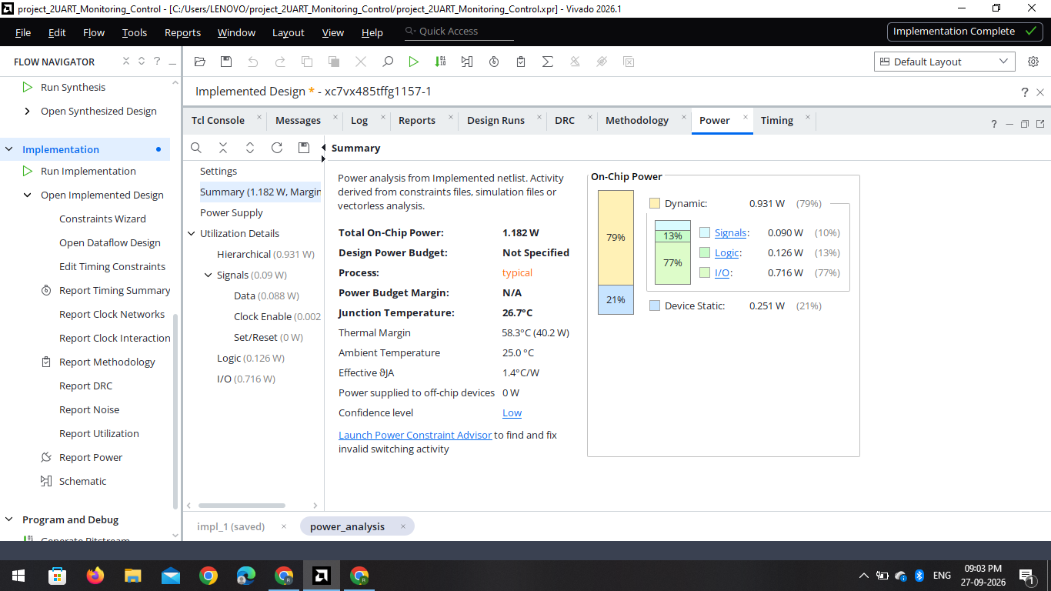
04_Power_Analysis.png
Conclusion
The UART-Based Digital Monitoring and Control System was successfully designed using Verilog HDL. The design was verified through simulation and analyzed using RTL schematic, synthesis, implementation, and power analysis in Xilinx Vivado.
This project provided practical experience in UART communication, Verilog HDL, digital design, and the VLSI design flow.

